INFORMATION SECURITY ANALYSIS AND AUDIT
PROJECT REPORT

Members:
B K Anirudh – 19BIT0348
Sompalli Yeswin – 19BIT0134
Manam Lakshmi Nivas – 19BIT0189

SERVER STRESS TEST FOR DdoS ATTACK USING ENSEMBLE TECHNIQUE
ABSTRACT
Attacks on the web servers and web application is the most common form of
attacks that are carried out nowadays. The main reason being is most of the web
application or services are vulnerable to attacks and can be easily compromised.

One of the popular attacks used is DdoS.

DDoS stand for Distributed denial of services. Most recent websites and web
servers are unable to withstand strong attacks like a DDoS attack. These private
servers don't have protection against simple attacks and are easily compromised.
Distributed Denial of Service (DDoS) attacks are the most damaging attacks that
block everyone from using your services. Websites and applications face cyber
threats daily by cyber attackers who want to exploit any IT infrastructure
vulnerability. Once your website or IT infrastructure is compromised, your
business processes and sensitive data face imminent threats that can bring down
your organization. It is vital to test your website and applications for protection
against DDoS attacks.

PROBLEM STATEMENT

Testing the stress on the server during such attacks and improve the security on
basis of the level of withstanding of website during such attacks as Distributed
Denial of Service (DDoS) attacks are some of the most common, notorious, and
damaging cyber attacks. These attacks cause a great deal of money to
organizations by bringing down their website and interrupting business
processes and consumer service.

LITERATURE SURVEY

Paper | Algorithm | Advantages | Issues | Metrics used
DDoS Attack Detection Method Based on SVM in Software Defined Network | Support vector machine learning algorithm | By sdn experimental environment the detection rate is high and false alarm is low | Very high time complexity | Accuracy
ML Based Application Layer DdoS Attack Detection Using Artificial Neural Networks | Multilayer Perceptron with genetic machine learning algorithm(MLP-GA), Back propagation algorithm | Correct and precise evaluation metric values and has achieved accuracy of 98% | The prevention mechanism is not illustrated in the paper | Accuracy
Ddos Attack Detection and Mitigation Using ML: Methods, Practices and Solutions | Artificial Neural networks, Self organizing map, Fuzzy logic | i)low performance overhead in switches and routers  ii)Not only scales better but also supported by large switch vendors | This Model is not a silver bullet solution to all types of DDoS attacks | i)Entropy  ii)Connection rate
Distributed denial of service attack detection using Naive Bayes and KNN | Navie bayes and k nearest neighbour | The detection rate is high in both knn and naive algorithm | Compared to naive bayes algorithm knn performed with more accuracy | Accuracy
DoS/DDoS Attack Detection Using Artificial Neural Networks | Artificail Neural Network | Detected known ddos attacks with full cent and with unknown it detected upto 96% | it cannot handle DDoS attacks that use encrypted packet headers. | Accuracy
Use the ensemble methods when detecting DoS attacks in Network Intrusion Detection Systems | Bagging, Adaboost and Voting as ensembling qualifier.  NaiveBayes,Random tree and KNN as classifiers | Optimized time complexity and has a metric of 98.76% | NaiveBayes and Random tree classifiers are not best Classifiers | F-score  precision  Accuracy
DDoS Attack Detection Method Based on Machine Learning. | Random forest algorithm Machine learning. | By using machine learning method for the DDoS attack has a good detection rate for the current popular DDoS attacks . It can extract the DDoS attacks out . | Takes time to detect the traffic characteristics with a large proportion. | Packets (TCP, UDP and ICMP) of the DDOS attack tools.
DDoS attack detection method based on improved KNN with DDoS | K-Nearest Neighbors (KNN) algorithm | The algorithms are identified the DDoS attack better, and the algorithms have achieved higher detection rates compared with the existing methods and solutions . | Does not work well with large dataset  Does not work well with high dimensions  Sensitive to noisy data, missing values and outliers | Accuracy
DoS/DDoS Attack Detection Using Artificial Neural Networks | Artificail Neural Network | Detected known ddos attacks with full cent and with unknown it detected upto 95% | it cannot handle DDoS attacks that use encrypted packet headers. | Accuracy
A Survey on Slow DDoS Attack Detection Techniques | Six classifiers of random forest, KNN, logistic regression, SVM, and deep neural networks, CUSUM algorithm | The high detection rate of 99.905% in random forest.  Average attack detection time of 32 seconds.  Ease of implementation, Ease of detection because attacks stress the server’s resources | Only slowloris attack was considered, Only slow header and slow POST were examined | Accuracy and precision
ML method for detecting DDoS attacks in the application layer | Neural Networks Genetic algorithm, Support vector machine (SVM), Fuzzy estimator | shows 98% of attacks generated by the tools have been detected effectively. | High time complexity | Accuracy
Server test for detecting Ddos Attcak: A Hybrid machine learning approach learning approach | SVM,NaiveBayes,KNN and Random frost | Less time complexity | Less accuracy of 93% | Accuracy
Smart Detection: An Approach for DoS/DDoS Attack Detection Using Machine Learning | Random Forest, Logistic Regression, AdaBoost, Stochastic gradient descent, and a perceptron. | i) Low false alarm rate  ii) High accuracy of 96% | i)Need improved hit rate among attack classes  ii)Automatic parameter calibration is missing | Accuraacy

SUMMARY

The papers [3][5][9][11] has used Neural network method for the prediction of chronic kidney disease, this is also a supervised learning model which comes under classification technique, Basically neural network is made of multiple layers where each layer consists of multiple neurons based on the attributes we have chosen and there will be classification at each layer based on the dependent variable and the output will be binary like yes or no.Out of disadvantages the paper [5][11] given high accuracy as we train more and one of the major issue is time complexity it takes a bit more time than the other models at smaller datasets and obviously giving good results for higher datasets than remaining.

The papers [10][13] has used Logistic Regression to predict the class label. This is also a supervised ML model where it gives the probality of dependent variable Basically in this model the dependent variable is classified into binary present as 1 and not present as 0.

The papers [6][7][10][13] has used Random forest method for prediction of chronic kidney disease. This algorithm basically consists of multiple decision trees where it is trained through aggregating and it basically produces outcome based on the predictions of decision tree, It predicts by taking average of the outputs from the tree.

The papers [1][10][11][12] has used SVM method for the prediction of incoming traffic. Basically almost all the papers are have a categorially dependent attribute like having yes or no.So they went with classification algorithms where it plots each and every data item treated as a point in n-dimensional space because there are n several features here. The value of a particular coordinate has a specific segment and then it classify based on the dependent attribute.

SYSTEM ARCHETECTURE

HIGH LEVEL DESIGN

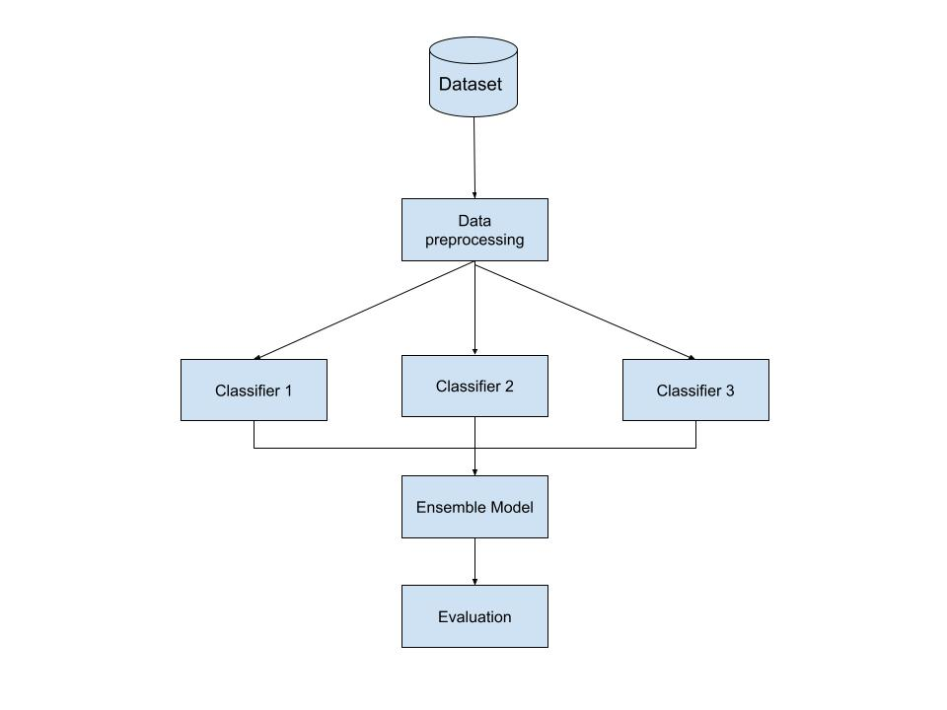

LOW LEVEL DESIGN

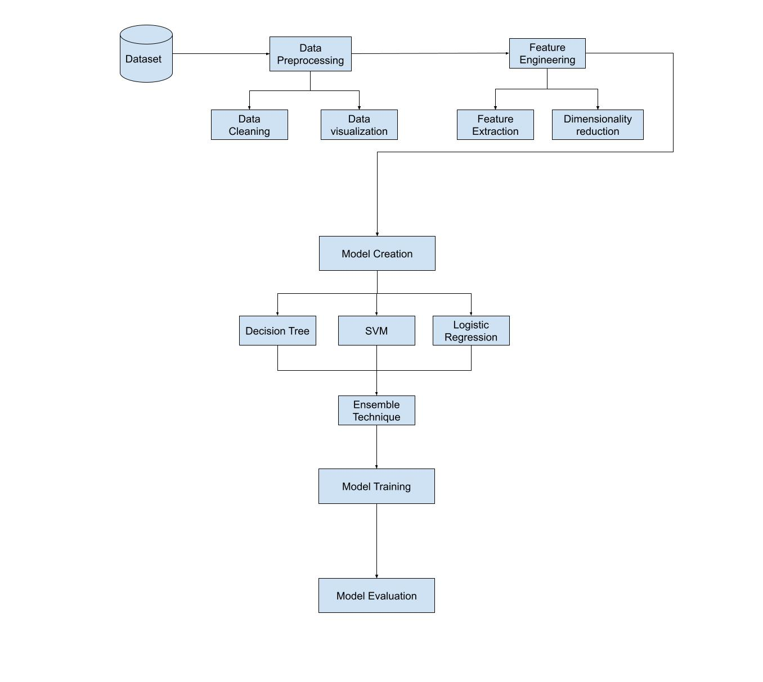

ARCHITECTURE DESCRIPTION

Dataset:

Application layer Dos Attack dataset from Kaggle which cosist of nearly 700000 rows and 78 columns with one class label.Class lable has three classifications Benign, DosHulk, Dosslowloris.
Data Preprocessing:
Data preprocessing is a process of preparing the raw data and making it suitable for a machine learning model. It is the first and crucial step while creating a machine learning model. When creating a machine learning project, it is not always a case that we come across the clean and formatted data. And while doing any operation with data, it is mandatory to clean it and put in a formatted way. So, for this, we use data preprocessing task. It has steps like Getting the dataset, importing dataset, Finding the missing data, Encoding the categorical data, Splitting the dataset between training and testing.
Feature Engineering:
Feature engineering is the process of selecting, manipulating, and transforming raw data into features that can be used in supervised learning. In order to make machine learning work well on new tasks, it might be necessary to design and train better features. We used Data visualization techniques for knowing correlation between atrributes of the dataset and finding outlayers and correction of them
Ensemble Technique:
Ensemble technique combine the decisions from multiple models to improve the overall performance of the model.In this approach we considered multiple models namely decision tree,LogisticRegression,SVM made as estimaters now all these models will predict the output for the data which is present after training. We have used Voting classifier which is the max voting method. This is generally used for classification problems. In this technique, multiple models are used to make predictions for each data point. The predictions by each model are considered as a ‘vote’. The predictions which we get from the majority of the models are used as the final prediction.

PSEUDO CODE FOR ENSEMBLE TECHNIQUE
initialize j = 1
initialize li = []
initialize li2 = []
initialize count = 0
for i in range(length(x_test)):
p1 = logmodel.predict(x_test.iloc[i:j])\\logestic regression
p2 = clf.predict(x_test.iloc[i:j])\\Decision tree
p3 = svm.predict(x_test.iloc[i:j])\\Support vector machines
li.append(p1[0])\\prediction result of logistic regression
li.append(p2[0])\\prediction result of decision tree
li.append(p2[0])\\prediction result of svm
increment j
if(li.count(1)>li.count(0)):
pred = 1
else:
pred = 0
li2.append(pred)\\li2 contains all three classifiers predictions
ensemble_pred = np.array(li2)\\conver li2 to numpy array for model evaluation
print(classification_report(y_test,ensemble_pred))

At the very first step, we intialize the variables.
We loop over x_test and store the results of logestic regression,decision tree, Support vector machine predictions in p1,p2,p3 respectively.
Then we extract them in to a list.
This list is then converted to numpy array which can be used for model evaluation with y_test.

This is how ensemble technique works at the backend.

IMPLEMENTATION CODES
from mpl_toolkits.mplot3d import Axes3D #For Basic ploting
from sklearn.preprocessing import StandardScaler #Preprocessing
from sklearn.preprocessing import MinMaxScaler
from sklearn import preprocessing
# Preprocessing
from sklearn.naive_bayes import GaussianNB #import gaussian naivebayes model
from sklearn.tree import DecisionTreeClassifier #import Decision treeclassifier
from sklearn import metrics #Import scikit-learn metrics module foraccuracy calculation
import matplotlib.pyplot as plt # plotting
import numpy as np # linear algebra
import os # accessing directory structure
import pandas as pd # data processing, CSV file I/O (e.g. pd.read_csv)
import scipy.optimize as opt
from sklearn import preprocessing
from sklearn.model_selection import train_test_split
from sklearn.metrics import accuracy_score, confusion_matrix
from sklearn.ensemble import RandomForestClassifier
from sklearn import svm
from sklearn.tree import DecisionTreeClassifier
import warnings
warnings.filterwarnings("ignore")

def plotPerColumnDistribution(df, nGraphShown, nGraphPerRow):
nunique = df.nunique()
df = df[[col for col in df if nunique[col] > 1 and nunique[col] < 50]] # For displaying purposes, pick columns that have between 1 and 50 unique values
nRow, nCol = df.shape
columnNames = list(df)
nGraphRow = (nCol + nGraphPerRow - 1) / nGraphPerRow
plt.figure(num = None, figsize = (6 * nGraphPerRow, 8 * nGraphRow), dpi = 80, facecolor = 'w', edgecolor = 'k')
for i in range(min(nCol, nGraphShown)):
plt.subplot(nGraphRow, nGraphPerRow, i + 1)
columnDf = df.iloc[:, i]
if (not np.issubdtype(type(columnDf.iloc[0]), np.number)):
valueCounts = columnDf.value_counts()
valueCounts.plot.bar()
else:
columnDf.hist()
plt.ylabel('counts')
plt.xticks(rotation = 90)
plt.title(f'{columnNames[i]} (column {i})')
plt.tight_layout(pad = 1.0, w_pad = 1.0, h_pad = 1.0)
plt.show()

from sklearn.metrics import classification_report,confusion_matrix
import itertools
def plot_cm(cm,classes,normalize=False,title='confusion matrix',cmap = plt.cm.Blues):
if normalize:
cm = cm.astype('float') / cm.sum(axis=1)[:,np.newaxis]
print('n cm')
else:
print('cm w n')
print(cm)
plt.imshow(cm, interpolation ='nearest', cmap = cmap)
plt.title(title)
plt.colorbar()
tick_marks = np.arange(len(classes))
plt.xticks(tick_marks,classes,rotation=45)
plt.yticks(tick_marks,classes)
fmt = '.2f' if normalize else 'd'
thresh = cm.max() / 2.
for i, j in itertools.product(range(cm.shape[0]),range(cm.shape[1])):
plt.text(j, i, format(cm[i, j], fmt),horizontalalignment="center",color="white" if cm[i, j] > thresh else "black")
plt.tight_layout()
plt.ylabel('True label')
plt.xlabel('Predicted label')

nRowsRead = 1000 # specify No. of row. 'None' for whole data
# test_mosaic.csv may have more rows in reality, but we are only loading/previewing the first 1000 rows
df1 = pd.read_csv('train_mosaic.csv', delimiter=',', nrows = nRowsRead)
df1.dataframeName = 'train_mosaic.csv'
nRow, nCol = df1.shape
print(f'There are {nRow} rows and {nCol} columns')

nRowsRead = None # specify No. of rows. 'None' for whole file
# train_mosaic.csv may have more rows in reality, but we are only loading/previewing the first 1000 rows
df2 = pd.read_csv('test_mosaic.csv', delimiter=',', nrows = nRowsRead)
df2.dataframeName = 'test_mosaic.csv'

df = pd.concat([df1,df2])
df.shape

X = df.drop('Label', axis=1)
y = df['Label']

scaler=MinMaxScaler((-1,1))
from imblearn.under_sampling import RandomUnderSampler
rus=RandomUnderSampler()
x_rus, y_rus = rus.fit_resample(X, y)
x=scaler.fit_transform(x_rus)
y = y_rus

from sklearn.model_selection import train_test_split
X_train, X_test, y_train, y_test = train_test_split(x, y, test_size=0.20)

classifier = DecisionTreeClassifier()
classifier.fit(X_train, y_train)
y_pred = classifier.predict(X_test)

clf = svm.SVC(kernel='linear') # Linear Kernel
clf.fit(X_train, y_train)
y_pred = clf.predict(X_test)

clf=RandomForestClassifier(n_estimators=100)
clf.fit(X_train,y_train)
y_pred=clf.predict(X_test)

rf1 = RandomForestClassifier(n_estimators=100)
dt1 = DecisionTreeClassifier()
svm1 = svm.SVC(kernel = 'linear')

from sklearn. ensemble import VotingClassifier
evc = VotingClassifier( estimators= [('rf1',rf1),('dt1',dt1),('svm1',svm1)],verbose=True)
print("Accuracy is {}".format(evc.score(X_test, y_test)))

IMPLEMENTATION SNAPSHOTS
Importing required libraries
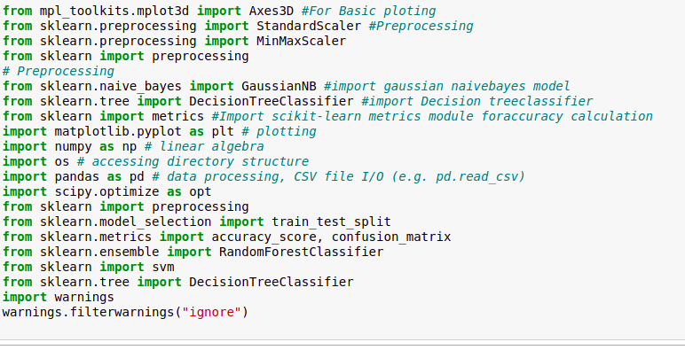
Writing a function for data visulization
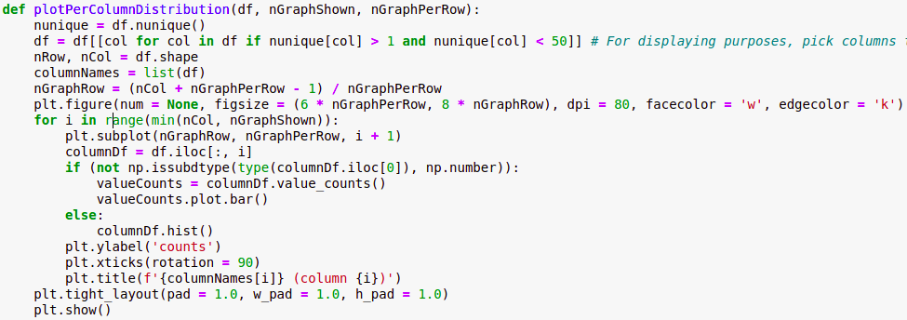

preparing the data
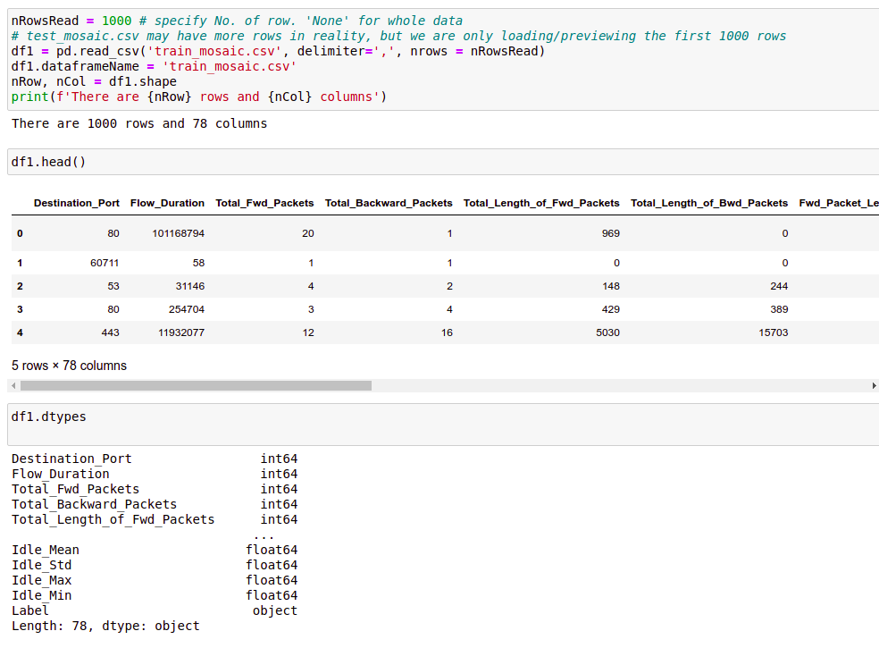
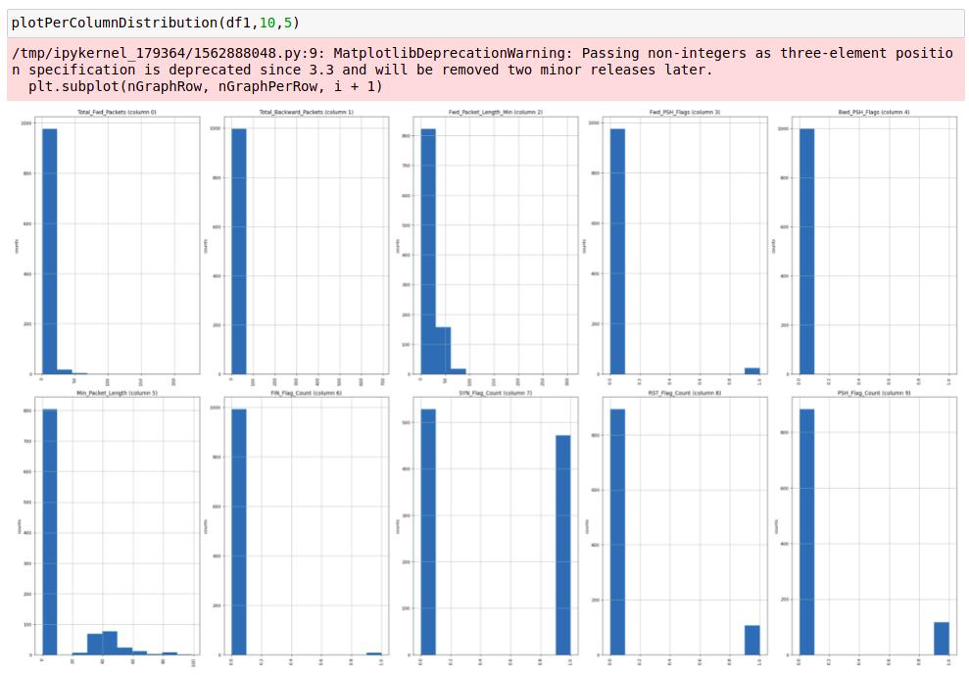
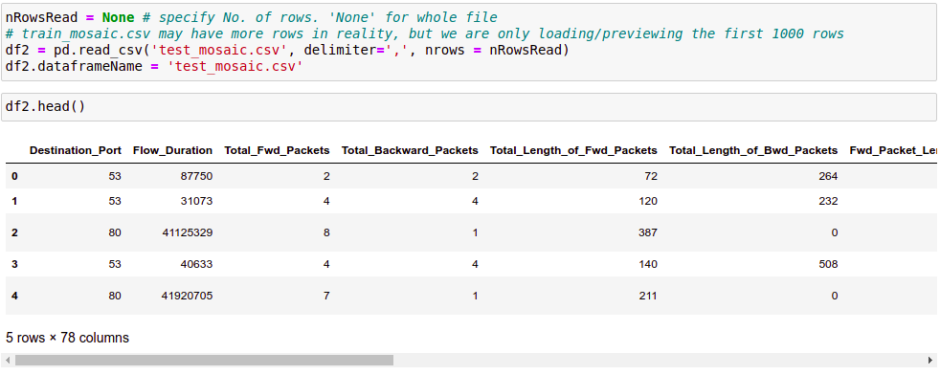
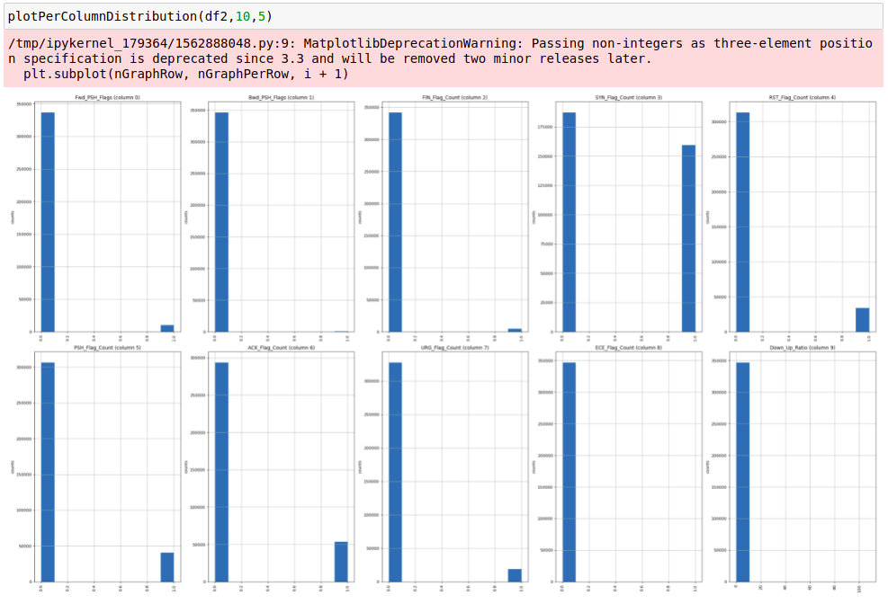

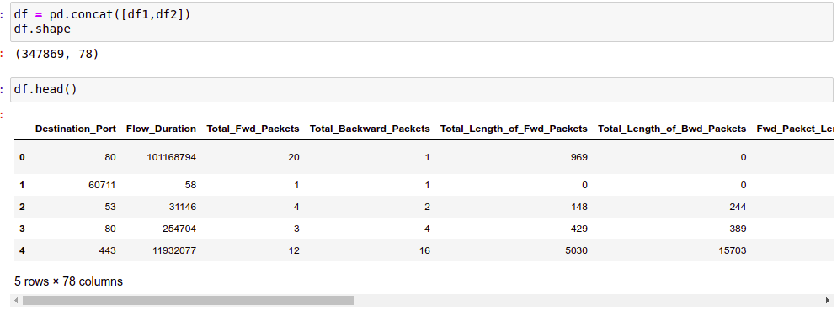
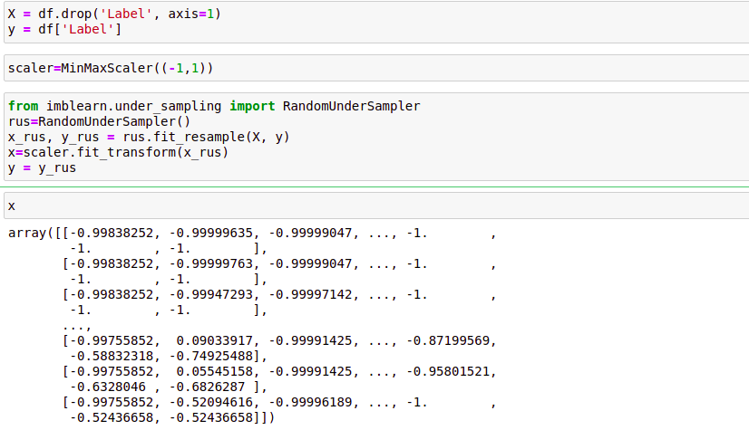

Splitting the data and training
Ensembling Technique:
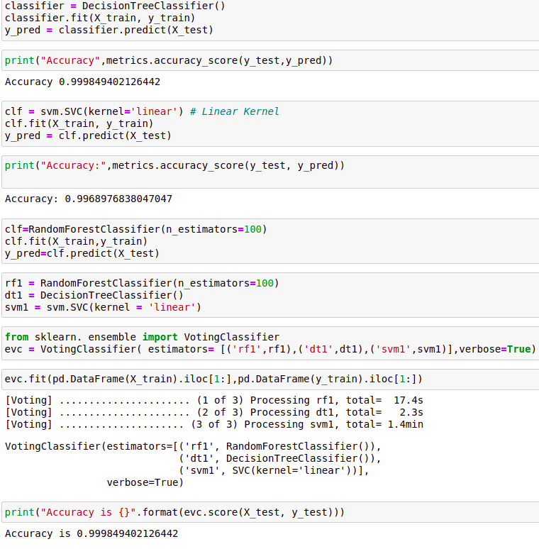
RESULT
Accuracy | 99.984

COMPARATIVE STUDY WITH EXISTING SYSTEM
In paper [6], they have used adaboost as boosting classifier and naive bayes,random frost and KNN as input model classifiers and achieved an accuracy score of 98.76% with optimized time complexity. We have implemented the ensemble model with random forest,support vector machine and decision tree input classifiers and achieved an accuracy of 99.98% which is so far the most accurate method. Although we could not achieved less time complexity, our model produced accuracy better than any other model.
CONCLUSION
DDoS attacks happen every day, and most of the time, it is hard to flag the ill-
intended traffic from normal traffic. However, you can be better prepared to
counter and have measures in place so that you can defend your website against
DDoS attacks by server stress testing. We have implemented a machine learning model to predict the type of incoming traffic and warn the IT companies by classification technique. We have produced a much better acuuracy(99.98%) than the existing models.

FUTURE WORK

We will combine this model with logistic regression based genetic algorithm to achieve greater time complexity and we also will incorporate a user interface for this project and try to deploy.

